Interesseorganisationer, foreninger og uddannelser indenfor det infektionshygiejniske fagområde

European Centre for disease prevention and Control | ECDC Virtual Academy (europa.eu)  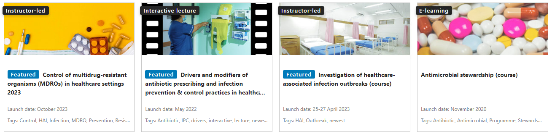
European Society of Clinical Microbiology and Infectious Diseases (ESCMID) | ESCMID: ESCMID - Home  ESCMID: ESCMID Courses and Workshops  ESCMID: ESGNI Study Group for Nosocomial Infections
Healthcare Infection Society (HIS) | Healthcare Infection Society - Healthcare Infection Society (his.org.uk)  Brittisk interesse- og vidensorganisation for infektionshygiejne
International Federation of Infection Control(IFIC) | Home | IFIC (theific.org)  International interesse- og vidensorganisation for infektionshygiejne
Central Enhed for Infektionshygiejne (CEI) | Arbejdsgrupper  NIR  AMR netværksgruppe  ad hoc arbejdsgrupper  Auditor-kursus i infektionshygiejne 2023 (ssi.dk)  Fagligt Forum
Rådet for bedre hygiejne | Rådet for Bedre Hygiejne | Forebyggelse og sundhed
Dansk Selskab for Infektionsforebyggelse (DSIF) | Velkommen til DSIF's hjemmeside | DSIF
Göteborg Universitet | Magisterprogram i mikrobiologi, smittskydd och vårdhygien | Göteborgs universitet (gu.se) To-årigt halvtidsstudie, 60 ECTS point/högskolepoäng  Nordic research network on infection control Gothenburg University has by support from the Nordic Council of Ministers established a Nordic research network on infection control with yearly seminars in Gothenburg. The next seminar will be September 18-21, 2023. All researchers in infection control are welcome to present their project.
Nordic Society of Clinical Microbiology and Infectious Diseases (NSCMID) | Home (nscmid.org)  NSCMIC Annual Meeting 2023 in Örebro, Sweden, September 21-24 2023

